The Roman Catholic Federation of Holy Name and Our Lady’s

Accessibility Plan 2024-2026

HOLY NAME MISSION STATEMENT

The Holy Name Primary School is a voluntary aided, inclusive, Roman Catholic School serving the children of the Our Lady’s with St Alphonsus and neighbouring parishes.

The school exists to help the Catholic Community fulfil the promise made to each child when welcomed in Baptism by the promotion of Catholic values in school. This is undertaken in partnership within the home and parish.

Recognising the variety of children’s backgrounds, the Governors and staff seek to be sensitive to and cater for their individual needs. We work to create a safe and secure environment with consistency, tolerance and generosity of time for all members of our school community.

We emphasise the positive aspects of all parts of school life, teaching the children about their value and worth and at the same time having high expectations in relation to academic and personal development.

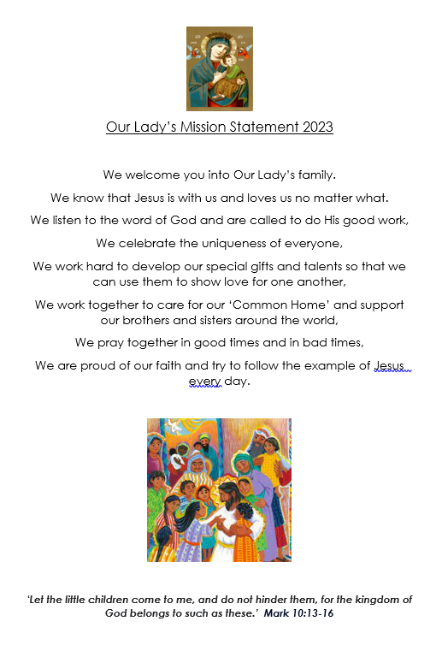
- This Accessibility Plan has been drawn up in consultation with the staff and governors of the school and has been reviewed March 2024.

- We are committed to providing a fully accessible environment which values and includes all pupils, staff, parents and visitors regardless of their education, physical, sensory, social, spiritual, emotional and cultural needs. We are committed to challenging negative attitudes about disability and accessibility and to developing a culture of awareness, tolerance and inclusion

- The Roman Catholic Federation of Holy Name and Our Lady’s, plans over time, to continue to increase the accessibility of provision for all pupils, staff and visitors to the school. The Accessibility Plan will contain relevant actions to:
• Improve access to the physical environment of the school, adding specialist facilities as necessary. This covers improvements to the physical environment of the school and physical aids to access education.
• Increase access to the curriculum for pupils with a disability, expanding the curriculum as necessary to ensure that pupils with a disability are as, equally, prepared for life as are the able-bodied pupils; (If a school fails to do this they are in breach of the DDA).
• This covers teaching and learning and the wider curriculum of the school such as participation in after-school clubs, leisure and cultural activities or school visits. It also covers the provision of specialist aids and equipment, which may assist these pupils in accessing the curriculum. Improve the delivery of written information to pupils, staff, parents and visitors with disabilities. Examples might include handouts, timetables, textbooks and information about the school and school events. The information should be made available in various preferred formats within a reasonable time frame.

- Below is our Action Plan, relating to these key aspects of accessibility. This plan will be reviewed and adjusted
on an annual basis or as required.

- We acknowledge that there is a need for ongoing awareness raising and training for staff and governors in the matter of disability discrimination and the need to inform attitudes on this matter.
- The Accessibility Plan should be read in conjunction with the following policies, strategies and documents: Equal opportunities, Health & Safety (including off-site safety) SEND Policy, Behaviour Policy, School Improvement Plan, and the school’s Mission Statement.

7. The Action Plan for physical accessibility relates to current and projected needs and funding.

8. As curriculum policies are reviewed, a section relating to access will be added to that on Equality and Diversity.

9. The School Website will feature the Accessibility Plan under ‘Policies’.

10. The Plan will be monitored through the Health, Safety and Premises Committees of the Governors.

11. The school will work in partnership with the Diocesan Authority in developing and implementing this plan.

12. The Plan may be monitored by Ofsted as part of their inspection cycle. The school meets the requirements of the
Disability Equality Scheme.

Improving access to the physical environment

Targets | Strategies | Timescale | Responsibility | Success Criteria
To be aware of the access needs of disabled children, staff, governors and parents/carers | -To create access plans for individual disabled children as part of the inclusion process  -Annual reminder to parents and carers through newsletter to let us know if they have problems with access to areas of school  -Staff to share SEND information with all agencies and support staff to ensure continuity of care for the children | As required  Ongoing process | Inclusion Team/Class Teacher | IEP’s are in place for disabled pupils and all staff are aware of pupil’s needs. Inclusion team to advise about training for staff regarding particular disabilities  Continuously monitored to ensure any new needs arising are met  Parents have full access to all areas of school  All agencies and Support Staff are aware of needs of SEN children at all times and are working with them accordingly
Ensure the school staff and governors are aware of access issues |  | Staff dealing with children with specific needs to be fully informed at the beginning of each term | Head of School/Health and Safety governor
Ensure everyone has access to reception area | -Ensure that nothing is preventing wheelchair access  -Ensure provision of appropriate seating | Daily check to ensure the area is clear of obstructions  Ensure that appropriate seating is available to all wheelchair users | Caretaker/Health and Safety Governor/Head of School | Disabled parents/carers/visitors feel welcome  Children/Adults have appropriate seating
Maintain safe access for visually impaired people | Check exterior lighting is working on a regular basis  Yellow paint on any step edges | Ongoing checks | Caretaker/Property Management team | Visually impaired people feel safe in school grounds.  External lights to be checked and working
Ensure all disabled people can be evacuated safely | Ensure there is a personal emergency evacuation plan for any disabled pupils  Ensure that all staff are aware of their responsibilities in an evacuation with regards to SEND information  Any wheelchair users must be made aware of the most efficient exit route in case of emergency | Ongoing – as and when needed | Head of School to remind staff | All disabled pupils and staff working with them are safe in the event of a fire  There is constant supervision for disabled children who would need help in the event of an evacuation.  Wheelchair users can be evacuated quickly and easily
Ensure there are enough fire exits around school that are suitable for people with a disability  Ensure that all outdoor learning areas are accessible for people with a disability | Ensure staff are aware of the need to keep fire exits clear  Ensure that all routes are clear and risk assessed by staff and outside agencies | Daily | All staff | Everyone including disabled personnel and pupils have safe independent exits from school  All children have access to outdoor areas
Training for awareness raising equality issues | Provide training for all stake holders as needed  Discuss perception issues with staff to determine the current status of the school | Ongoing involvement as required | Inclusion team | Community will benefit from an inclusive environment
Ensure all Staff including Support Staff have specific training on disability issues including early identification of and teaching children with, SEND | Identify training needs at regular meetings | Ongoing | Inclusion team/Head of School | Raised confidence of all staff including support staff
Improving access to and participation within the curriculum
Class rooms are optimally organised to promote participation and independence of all pupils | Audit needs of children and organise the classroom furniture etc. to support the needs of all children to take part fully in all curriculum areas with appropriate independence. | Ongoing | Class teacher/Inclusion team | Children able to move round freely, access resources for learning independently and take part in all areas of learning
Review PE curriculum to ensure PE is accessible to all pupils | Review PE curriculum to include disability sports | Ongoing | Inclusion Team and PE Co-ordinator | All pupils have access to PE and are able to excel. Support staff for individuals will. will be there according to needs plan
All school visits and trips need to be accessible to all pupils | Ensure venues and means of transport are vetted for suitability.  Develop guidance on making trips accessible | Ongoing | EVC Co-ordinator | All pupils are able to access all school trips and take part in a range of activities
Review curriculum areas and planning to include disability issues | Include specific reference to disability equality in all curriculum reviews | Ongoing | Inclusion team and Head of School | Gradual introduction of disability issues into all curriculum areas
Ensure disabled children can take part equally in after school activities | Discuss with all staff including people running other clubs after school.  Additional support may have to be available after school. | As required | Inclusion team | Disabled children feel able to participate equally in out of school activities.
Ensure that the medical needs of all pupils are met fully within the capability of the school | Liaise regularly with parents and other agencies involved with the child  Identify training needs | As required | Head of School | All advice acted upon. All pupils’ needs are met and they are able to access the curriculum.
Appropriate use of specialised equipment to benefit individual pupils and staff | Ipads available to support children with difficulties  Sloping boards for children with physical disabilities  Coloured overlays or coloured paper for children with visual difficulties or dyslexia  Use of wobble cushions, Pencil grips, fidget toys, chew toys etc  Monitor and observe use of equipment eg visual timetable, wobble cushions etc | Audit of resources | SENDCo | SEND children have appropriate equipment and resources which supports their learning and remove barriers to learning
All children are visible in the curriculum and resources | Resources will reflect the needs of the pupils.  Teachers will make a conscious effort to show a variety of people with additional needs in their classroom practice. | Ongoing | All staff | Children will be able to identify with characters in stories, historical figures and illustrations. They will feel seen in the curriculum and resources
Improve the access and delivery of written information
Review documentation on website to check accessibility for parents | Ensure documents are accessible to everyone using commonly known vocabulary.  Office to be aware of parents who may need support in accessing materials and assisting with this. | Ongoing | Head of School/Business Manager | All parents will be able to be aware of what is happening at school via the website.
Ensure written materials are available in alternative formats | Ensure office staff are able to use google translate to translate any written letters and newsletters and ensure parents know this is available.  Ensure parents with visual impairments can access support to read documents  Invite parents in who may need support completing forms | Ongoing | Business Manager/Office Staff | Parents are able to access all information

