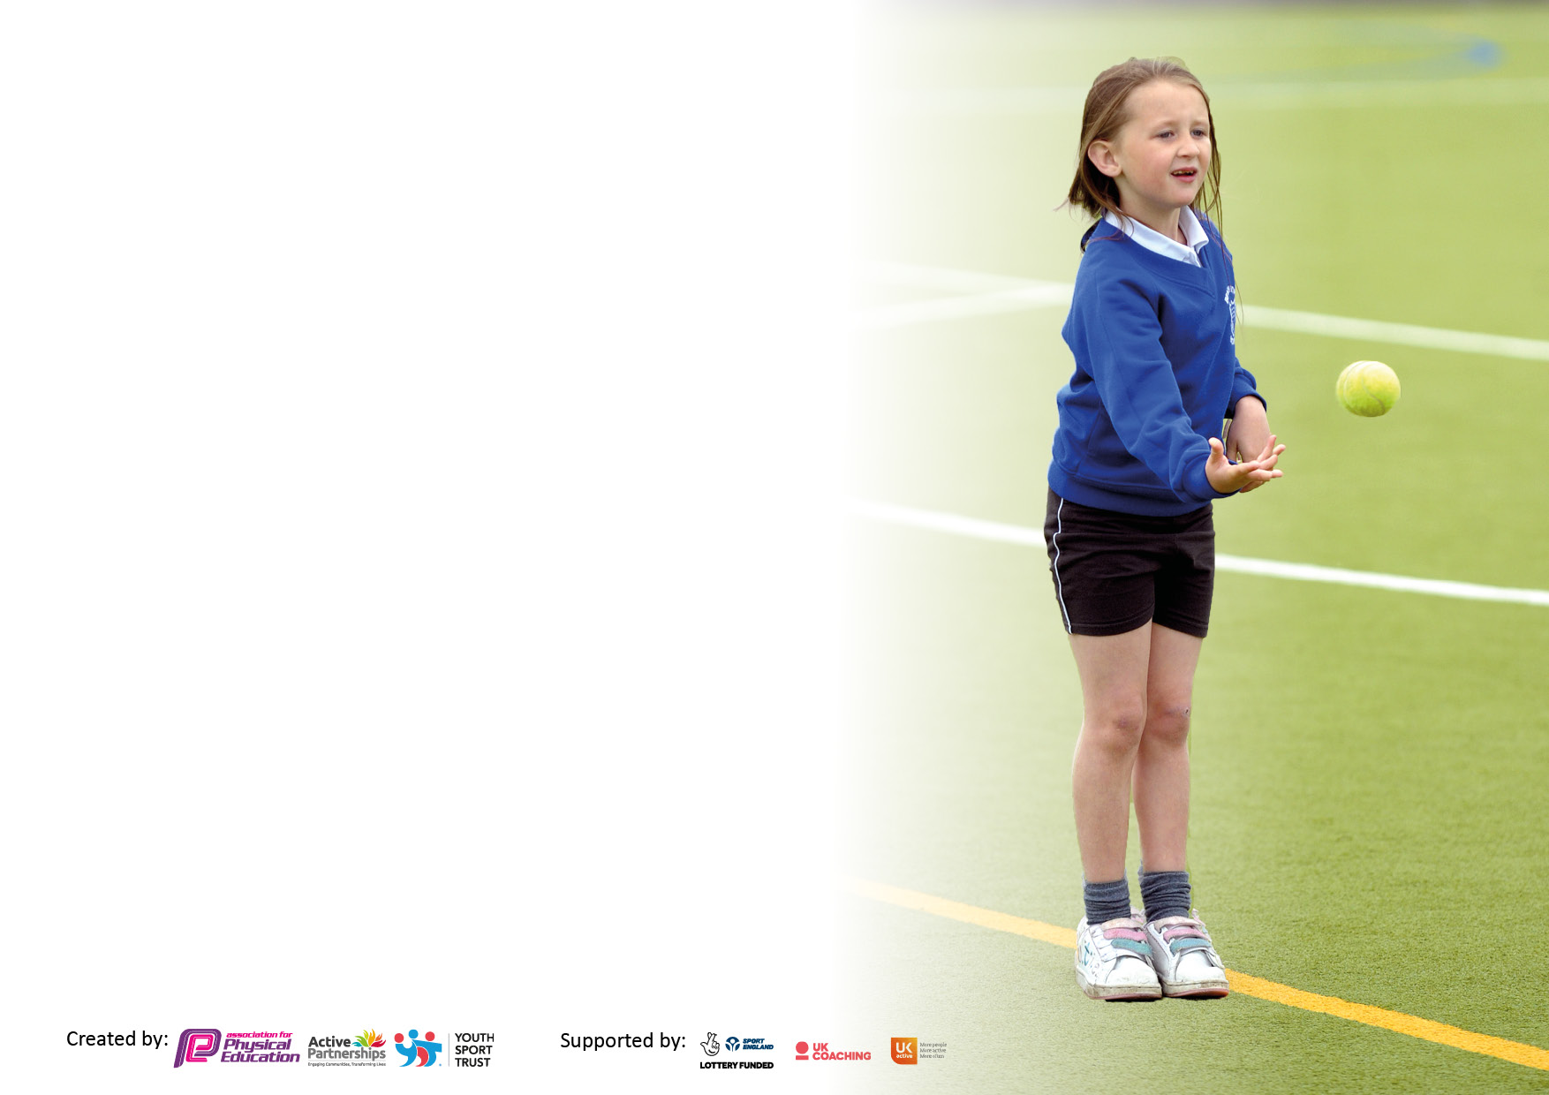

It is important that your grant is used effectively and based on school need. The [Education Inspection Framework](https://www.gov.uk/government/publications/education-inspection-framework) makes clear there will be a focus on **‘whether leaders and those responsible for governors all understand their respective roles and perform these in a way that enhances the effectiveness of the school’**.

Under the Quality of Education judgement, Ofsted inspectors consider:

**Intent** - Curriculum design, coverage and appropriateness

**Implementation** - Curriculum delivery, teaching (pedagogy) and assessment

**Impact** - Attainment and progress

To assist schools with common transferable language, this template has been developed to utilise the same three headings which should make your plans easily transferable between working documents.

Schools must use the funding to make additional and sustainable improvements to the quality of Physical Education, School Sport and Physical Activity (PESSPA) they offer. This means that you should use the Primary PE and sport premium to:

* Develop or add to the PESSPA activities that your school already offers
* Build capacity and capability within the school to ensure that improvements made now will benefit pupils joining the school in future years
* The Primary PE and sport premium should not be used to fund capital spend projects; the school’s budget should fund these.

Please visit <https://www.gov.uk/guidance/pe-and-sport-premium-for-primary-schools> for the revised DfE guidance, including the 5 key indicators across which schools should demonstrate an improvement. This document will help you to review your provision and to report your spend. DfE encourages schools to use this template as an effective way of meeting the reporting requirements of the Primary PE and Sport Premium.

We recommend you start by reflecting on the impact of current provision and reviewing the previous spend.

Schools are required to publish details of how they spend this funding, including any underspend from 2021/2022, as well as on the impact it has on pupils’ PE and sport participation and attainment.

We recommend regularly updating the table and publishing it on your website throughout the year. This evidences your ongoing self-evaluation of how you are using the funding to secure maximum, sustainable impact. Final copy must be posted on your website by the end of the academic year and no later than the 31 July 2023.

**Details with regard to funding**

Please complete the table below.

|  |  |
| --- | --- |
| Total amount carried over from 2023/2024 | £0.00 |
| Total amount allocated for 2023/2024 | £17950 |
| How much (if any) do you intend to carry over from this total fund into 2024/2025? | £0.00 |
| Total amount allocated for 2024/25 | £17650 |
| Total amount of funding for 2024/25 to be reported on by 31st July 2025 | £17650 |

**Swimming Data**

Please report on your Swimming Data below.

|  |  |
| --- | --- |
| Meeting national curriculum requirements for swimming and water safety.  **N.B.** Complete this section as best you can. For example, you might have practised safe self-rescue techniques on dry land which you can then transfer to the pool when school swimming restarts.  **Due to exceptional circumstances priority should be given to ensuring that pupils can perform safe self-rescue even if they do not fully meet the first two requirements of the NC programme of study** |  |
| What percentage of your current Year 6 cohort swim competently, confidently and proficiently over a distance of at least 25 metres?  **N.B.** Even though your pupils may swim in another year, please report on their attainment on leaving primary school at the end of the summer term 2023.  Please see note above | 77% |
| What percentage of your current Year 6 cohort use a range of strokes effectively [for example, front crawl, backstroke and breaststroke]?  Please see note above | 65% |
| What percentage of your current Year 6 cohort perform safe self-rescue in different water-based situations? | 61% |
| Schools can choose to use the Primary PE and sport premium to provide additional provision for swimming, but this must be for activity **over and above** the national curriculum requirements. Have you used it in this way? | No |

**Action Plan and Budget Tracking**

Capture your intended annual spend against the 5 key indicators. Clarify the success criteria and evidence of impact that you intend to measure to evaluate for pupils today and for the future.

|  |  |  |  |  |
| --- | --- | --- | --- | --- |
| **Academic Year:** 2024/2025 | **Total fund allocated:£17650** | **Date Updated: 24/09/2024** | |  |
| **Key indicator 1:** Increase confidence, knowledge and skills of all staff in teaching PE and sport | | | | Percentage of total allocation: |
| 51% |
| **Intent** | **Implementation** | | **Impact** |  |
| Your school focus should be clear on what you want the pupils to know and be able to do. What do they need to learn and to consolidate through practice: | Make sure your actions to achieve are linked to your intentions: | Funding allocated: | Evidence of impact:  What do pupils now know and what can they now do? What has changed? | Sustainability and suggested next steps: |
| Improve subject knowledge and variety of lessons taught  Other CPD opportunities through other external agencies | Continue links with Manchester City across the whole school including EYFS so all class teachers receive quality CPD | £9000 | Teachers will become more confident in delivering high quality curriculum PE and sport and be able to adapt plans to meet pupil’s needs | PE subject Leader to support all staff in school with planning the delivery of physical education and to identify any staff who need further support and to provide appropriate professional learning. - Further professional learning opportunities for staff who request it.  PE Subject Leader to monitor and to provide support as appropriate in order to ensure progress and achievement are maintained by all pupils. |
| **Key indicator 2:** The engagement of all pupils in regular physical activity – Chief Medical Officers’ guidelines recommend that  primary school pupils undertake at least 30 minutes of physical activity a day in school | | | | Percentage of total allocation: |
| 11% |
| **Intent** | **Implementation** | | **Impact** |  |
| Your school focus should be clear on what you want the pupils to know and be able to do. What do they need to learn and to consolidate through practice: | Make sure your actions to achieve are linked to your intentions: | Funding allocated: | Evidence of impact:  What do pupils now know and what can they now do? What has changed? | Sustainability and suggested next steps: |
| Embed initiatives to develop knowledge of healthy living and active lifestyles across the whole school including EYFS  Increase physical activity and participation in EYFS, KS1 & KS2 at lunchtime, to engage pupils in at least 30mins of physical activity a day in school. | Continue with healthy school food and drink policy, offering KS1 milk scheme, KS2 milk and fruit scheme and ensuring school provides a healthy and nutritious lunchtime meal including fresh drinking water and milk  Continue to audit food at breakfast and after school club ensuring children are offered healthy options  Lunchtime  Organisers to receive ongoing training to enable them to organise activities to increase physical activity and exercise.  Investment in equipment for playtimes and lunchtimes and wrap around care  Encourage the daily mile across the school | £2000 | Increased uptake of milk throughout the school and increased uptake of children having fruit each day  Increased number of children taking a school meal each day  Pupils are knowledgeable regarding foods and healthy lifestyles.  Teachers regularly taking pupils out for Daily runs  Increased range of activities and physical activity during playtime and lunchtime | Funding and staffing allocated annually to enable provision |

|  |  |  |  |  |
| --- | --- | --- | --- | --- |
| **Key indicator 3:** The profile of PE and sport is raised across the school as a tool for whole school improvement | | | | Percentage of total allocation: |
| 16% |
| **Intent** | **Implementation** | | **Impact** |  |
| Your school focus should be clear on what you want the pupils to know and be able to do. What do they need to learn and to consolidate through practice: | Make sure your actions to achieve are linked to your intentions: | Funding allocated: | Evidence of impact:  What do pupils now know and what can they now do? What has  changed? | Sustainability and suggested next steps: |
|  |  |  |  |  |
|  |  |  |  |  |
|  |  |  |  |  |
|  |  |  |  |  |
| Improve subject knowledge and variety of lessons taught  New sports kits for children taking part in competitive sport  Purchase of equipment to enable staff to implement a broad and balanced PE curriculum | Specialised training to enhance Physical Education and playground games both indoors and outdoors- eg GLL Squash, LCC Cricket etc  Continue to be part of the Manchester PE Association including advice, guidance and participation  Renew purchase and continue to embed in the new PE scheme for curriculum planning and assessment – Get Set 4 PE  Ongoing CPD to continue to upskill PE subject leader | £2870 | Teachers will become more confident in delivering high quality curriculum PE and sport and be able to adapt plans to meet pupil’s needs  Pupils will become more skilled in a range of sports and activities and have improved attitudes to PE  Enrolled in PE Association  Accompanying staff to sports events are first aid qualified  Improved standards and pupil behaviour  Enhanced, inclusive curriculum provision | PE subject Leader to support all staff in school with planning the delivery of physical education and to identify any staff who need further support and to provide appropriate professional learning. - Further professional learning opportunities for staff who request it.  PE Subject Leader to monitor and to provide support as appropriate in order to ensure progress and achievement are maintained by all pupils. |
| **Key indicator 4:** Broader experience of a range of sports and physical activities offered to all pupils | | | | Percentage of total allocation: |
| 16% |
| **Intent** | **Implementation** | | **Impact** |  |
| Your school focus should be clear on what you want the pupils to know and be able to do. What do they need to learn and to consolidate through practice: | Make sure your actions to achieve are linked to your intentions: | Funding allocated: | Evidence of impact:  What do pupils now know and what can they now do? What has  changed? | Sustainability and suggested next steps: |
|  |  |  |  |  |
|  |  |  |  |  |
|  |  |  |  |  |
|  |  |  |  |  |
| Ensure that all children continue to take part in a range of activities that have a positive effect on their social, mental and emotional health  Continue with extension of end of year residential trip to Year 5 and 6 cohorts – trips to include water sports, orienteering, abseiling and camping and survival skills  Continue with coaching in new sports  Continue with opportunities for new sports | Support families with financing trips – subsidise provision of transport  Years 4 -6 Water sports activities  Years 1- 3 Climbing activities  Provide opportunities for class coaching in squash, taekwondo, and cricket across both key stages | £2780 | Pupil Voice evidence of children’s enjoyment of participation in a range of sports and activities  Increase in uptake in after school sports clubs  No financial barriers to children attending residential trips  Children will have experienced an increase in the range of activities on offer to them  Increased confidence in children’s willingness to try new activities  Pupil voice – children will feel confident to express their opinions and they will be listened to | Funding and staffing allocated annually to enable provision  Outside agencies / clubs coming into school to offer a range of sporting opportunities, develops further interest and links with local clubs, to enable children to participate outside of school. This gives children the opportunity to try some sports they may not otherwise get the chance to play |

|  |  |  |  |  |
| --- | --- | --- | --- | --- |
| **Key indicator 5:** Increased participation in competitive sport | | | | Percentage of total allocation: |
| 6% |
| **Intent** | **Implementation** | | **Impact** |  |
| Your school focus should be clear on what you want the pupils to know and be able to do. What do they need to learn and to consolidate through practice: | Make sure your actions to achieve are linked to your intentions: | Funding allocated: | Evidence of impact:  What do pupils now know and what can they now do? What has  changed? | Sustainability and suggested next steps: |
|  |  |  |  |  |
|  |  |  |  |  |
|  |  |  |  |  |
|  |  |  |  |  |
| Continue to take part in Manchester PE Association competitions  Continue to hold inter school competitions | Ensure there are sufficient staff to take children to competitive sport competitions  Continue to host competitive sport competitions here in school  Provision of transport to take competitors to sports competitions  To look at holding girls football and cricket competitions in addition to boys football | £1000 | Increase in number of children taking part in competitive sport  Increased number of children able to take part in competitions on school grounds | Funding and staffing allocated annually to enable provision  Develop intra-school competitions in conjunction with partner-school |

|  |  |
| --- | --- |
| Signed off by | |
| Head Teacher: | Catherine Gordon |
| Date: | 24/09/2024 |
| Subject Leader: | Adam Moore |
| Date: | 24/09/2024 |
| Governor: | Charles Flannery |
| Date: | 24/09/2024 |